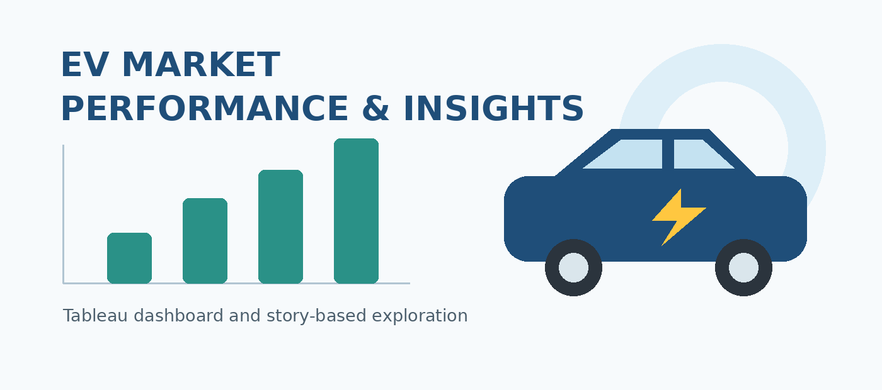

MEDICAPS UNIVERSITY, INDORE
SKILL WALLET PROJECT REPORT

EV MARKET PERFORMANCE
AND INSIGHTS USING TABLEAU
A dashboard and story-based exploration of electric-vehicle market attributes

Submitted by | Academic details
Nandini Singh Chauhan | B.Tech — Computer Science and Engineering
Enrollment No.: EN25CS3010610 | Second Year
Project platform: Skill Wallet | Medicaps University, Indore

Tools: Tableau Public, Flask, HTML and CSS
Dataset: ev_market_train.csv (Kaggle)

1. Introduction and Problem Understanding
Electric vehicles (EVs) are evaluated through several connected dimensions: price, driving range, battery characteristics, charging performance, vehicle category, manufacturer, customer rating and environmental impact. Looking at any one measure in isolation can provide an incomplete picture of market performance. This project organizes these dimensions into Tableau worksheets, dashboards and story points so that users can explore relationships and compare the attributes represented in the dataset.
The project uses the packaged Tableau workbook “Electronic Vehicles.twbx”. Its embedded data source is named “ev_market_train”, matching the stated Kaggle file ev_market_train.csv. The workbook contains nine analytical worksheets, two dashboards and two storyboards. The report describes the structure visible in the workbook and avoids presenting unverified numerical outcomes as facts.

1.1 Problem statement
To build an interactive visual analysis of EV market characteristics that helps users examine sales volume, price and range, manufacturer comparisons, production geography, battery technology, customer satisfaction and environmental impact.

1.2 Objectives
- Explore sales volume by vehicle and compare sales with range and price-related attributes.
- Compare manufacturers and vehicle categories using the measures included in the workbook.
- Review production and export distribution through manufacturing-country and drivetrain fields.
- Examine battery type, cycle life and five-year degradation alongside range and customer rating.
- Present the worksheets in dashboards and story points that guide a reader through related questions.
- Provide a basis for evidence-led recommendations while making the limitations of the available evidence explicit.

1.3 Scope
The scope is descriptive and exploratory. The workbook is designed to summarize attributes already present in the dataset; the inspected workbook does not establish causal relationships, prove market-wide representativeness, or document a predictive model. The analysis is limited to the data fields and views in the uploaded workbook.

2. Dataset and Data Architecture
The Tableau package contains a workbook file and a Hyper extract. The extract is embedded in the packaged workbook, allowing the workbook to retain its data connection. The source is identified in Tableau as “ev_market_train”. The Kaggle dataset page supplied for this project is listed in the references.

2.1 Data fields identified in the workbook
Field group | Fields represented
Identification | vehicle_id, model_name, manufacturer, model_year
Geography and market | manufacturing_country, market_region
Classification | category, battery_type, drivetrain, recommended_use_case
Battery and range | battery_capacity_kwh, battery_cycle_life, battery_degradation_pct_5yr, range_km
Performance and charging | efficiency_wh_per_km, motor_power_kw, torque_nm, num_motors, top_speed_kmph, acceleration_0_100_sec, max_dc_charging_kw, charging_dc_fast_time_min, charging_ac_time_hr, num_charging_ports
Vehicle attributes | num_seats, weight_kg, cargo_capacity_liters, infotainment_screen_inch, safety_rating_stars, autonomous_level
Cost and ownership | price_usd, insurance_cost_usd_yearly, warranty_years, resale_value_pct_3yr
Market and impact | annual_sales_units, customer_rating, co2_saved_tons_per_year

2.2 Data types and interpretation
The workbook metadata identifies fields such as vehicle identifiers, names, manufacturers, countries, regions, categories, battery types, drivetrain and use case as text dimensions. Year, number of motors, seats, charging ports, warranty years, safety stars and autonomous level are integer fields. Price, range, battery capacity, efficiency, sales units, rating and other continuous specifications are numeric fields.
Important validation note: the CSV itself was not supplied separately in this turn. The Tableau package contains a Hyper extract, but its row-level values could not be independently queried in this environment. Therefore, row count, missing-value totals, duplicate count, ranges, averages and exact top-ranked manufacturers are not reported as measured statistics.

3. Methodology and Tableau Workflow
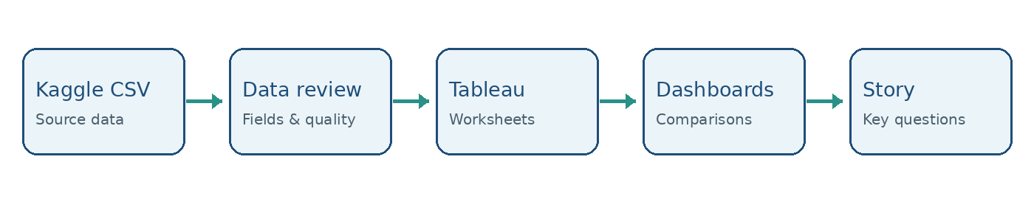
Figure 1. Project workflow schematic (conceptual sequence; not a measured result).
Phase | Activity | Evidence in uploaded workbook
1. Source selection | Choose the EV market training CSV as the data source. | Data source is named ev_market_train; packaged workbook includes a Hyper extract.
2. Field organization | Use vehicle, market, cost, performance, battery and impact attributes as dimensions/measures. | Field metadata contains the attributes listed in Section 2.
3. Worksheet creation | Build focused views around sales, range, price, manufacturer, production, battery and customer/impact questions. | Nine worksheet titles are present in the workbook.
4. Dashboard composition | Combine related worksheets for a broader overview. | Dashboard 3 contains Sheets 1–4; Dashboard 4 contains Sheets 5–9.
5. Storytelling | Arrange dashboards as story points with short explanatory captions. | Story 1 uses Dashboard 3; Story 2 uses Dashboard 4.
6. Presentation and sharing | Use Tableau Public and the project’s associated web/demo resources. | Student-provided demo and GitHub URLs are recorded in References.

3.1 Analytical approach
The workbook follows a descriptive visualization approach. Each worksheet narrows attention to a specific comparison, while dashboards combine related views and the storyboards provide a sequence. When interpreting the views, a reader should check the measure aggregation, unit, category definitions, and any active filters before comparing values.

3.2 Questions the analysis is designed to investigate
- How are sales units distributed across the vehicle categories represented in the data?
- How do range and price appear alongside annual sales volume?
- How do manufacturers compare on the fields included in the leaderboard view?
- Which manufacturing countries and drivetrain groups appear in the production/export views?
- How do battery type, cycle life and five-year degradation relate to the range and customer-rating views?
- How are customer rating and estimated annual CO₂ savings represented together?

3.3 Reproducibility
For a fully reproducible numerical report, the original CSV should be checked for record count, missingness, duplicates, units and outliers, and the results should be compared with the packaged Tableau extract. This report does not claim that these checks were completed because the CSV values were not independently accessible here.

4. Worksheet and Visualization Inventory
Worksheet | Title in workbook | Fields / analytical focus
Sheet 1 | Sales Volume by Vehicle | Category, annual_sales_units, price_usd; a Calculation1 field is also referenced.
Sheet 2 | Range vs Sales Volume | Battery type, manufacturer, annual sales units.
Sheet 3 | Vehicle Range vs. Price | Annual sales units, battery cycle life, five-year battery degradation.
Sheet 4 | Manufacturer Market Share Leaderboard | Category, price, range, recommended use case, annual sales units.
Sheet 5 | Production Hubs & Export Distribution | Category, drivetrain and range.
Sheet 6 | Production Hubs & Export Distribution | Manufacturing country and annual CO₂ saved.
Sheet 7 | Battery Technology & Degradation Profile | Annual sales units, category, customer rating and range.
Sheet 8 | Customer Satisfaction & Environmental Impact | Annual sales units and five-year battery degradation; pie mark type is configured.
Sheet 9 | Category vs. Battery Type | Battery type, category, customer rating and energy efficiency.

4.1 Reading the views responsibly
The worksheet titles indicate the questions each view is intended to support. However, titles alone do not establish the exact numerical outcome or statistical relationship. In particular, “market share” should only be interpreted as a share after confirming that the calculation uses an appropriate denominator and the relevant sales measure. Likewise, CO₂ saved is an estimated dataset field, not an independently verified emissions audit.

4.2 Calculated fields
The workbook metadata references a field named Calculation1, but its formula is not exposed as a readable calculation in the inspected workbook XML. Its business definition is therefore not asserted here. No other named calculated-field formula was verifiable from the workbook metadata inspected.

5. Dashboard and Story Design

5.1 Dashboard 3 — Sales and price-oriented overview
Dashboard 3 combines Sheets 1–4: Sales Volume by Vehicle, Range vs Sales Volume, Vehicle Range vs. Price, and Manufacturer Market Share Leaderboard. This grouping supports an initial review of sales volume and comparisons involving vehicle range, price, battery characteristics and manufacturer performance. The dashboard includes legends for fields such as battery type, battery cycle life, price and recommended use case, as recorded in the workbook layout.

5.2 Dashboard 4 — Distribution, battery and impact overview
Dashboard 4 combines Sheets 5–9. Its views cover drivetrain/category/range, manufacturing-country and CO₂-savings attributes, battery technology, customer satisfaction/environmental impact, and category versus battery type. This dashboard broadens the analysis from sales and price into geography, technology and customer/impact attributes.

5.3 Tableau Story points
Story | Story title | Story point caption / destination
Story 1 | Sales and Price | Caption says the dashboard provides information about sales, price and the share leaderboard; destination: Dashboard 3.
Story 2 | Distribution and Environmental factors | Caption says the dashboard gives information about export distribution, customer satisfaction and batteries; destination: Dashboard 4.

5.4 User experience
The two-story structure gives the audience a clear sequence: first inspect sales/price comparisons, then explore production distribution and battery/customer/environmental dimensions. During a presentation, the reader should state the question before each view, explain the axes and units, and finish with a conclusion that is supported by visible values rather than chart appearance alone.

6. Validation, Observations and Limitations

6.1 Workbook structure checks
Check | Result from workbook inspection
Packaged workbook readable | Yes — the .twbx archive contains Electronic Vehicles.twb and a Hyper extract.
Worksheets identified | Nine worksheet definitions identified.
Dashboards identified | Dashboard 3 and Dashboard 4 identified.
Stories identified | Story 1 and Story 2 identified, each with one story point in the inspected metadata.
Field metadata | Vehicle, market, cost, performance, charging, battery, customer and impact fields identified.
Numerical data-quality checks | Not independently verified from row-level data in this environment.
Live web application test | Not performed in this report; no browser/runtime test evidence was supplied.

6.2 Observations supported by the workbook design
- The workbook treats EV performance as multidimensional, using specifications, ownership cost, sales, customer ratings and environmental-impact fields.
- Sales and price questions are grouped separately from distribution and battery/customer/impact questions, which makes the story sequence easy to follow.
- The dataset fields support comparisons by manufacturer, category, battery type, drivetrain, market region and manufacturing country.
- The presence of range, efficiency, charging-time, battery-life and degradation fields supports an exploratory view of practical vehicle trade-offs.

6.3 Limitations
- Exact counts, averages, rankings, correlations and percentage shares are omitted because row-level CSV values were not independently analysed.
- The workbook metadata alone cannot verify missing values, duplicate records, data provenance for each field or whether units are consistent.
- The workbook’s Calculation1 formula was not readable in the inspected metadata.
- The stated Flask/HTML/CSS integration is included as project context, but the source code and a live execution test were not part of the uploaded Tableau package.
- The dataset’s coverage and representativeness should be checked before generalizing results to the entire EV market.

7. Conclusion, Future Scope and References
Analysis layer | Workbook evidence | Interpretation boundary
Sales and price | Dashboard 3; Sheets 1–4 | Use actual chart values to make rankings or numeric claims.
Distribution and technology | Dashboard 4; Sheets 5–9 | Confirm categories, filters and units before comparisons.
Storytelling | Two storyboards | Captions describe intended focus, not numerical findings.

7.1 Conclusion
The uploaded Tableau workbook presents a structured exploratory view of electric-vehicle market attributes through nine worksheets, two dashboards and two storyboards. The first dashboard/story focuses on sales and price-oriented comparisons, while the second explores production distribution, battery technology, customer satisfaction and environmental factors. The workbook’s field structure supports a broad descriptive discussion of EV performance and market positioning.
The report intentionally distinguishes verified workbook structure from numerical findings. Before submission, the embedded extract should be checked against the original CSV and the final dashboard should be reviewed interactively so that quantitative claims, chart labels and any calculated metrics can be validated.

7.2 Future scope
- Add a data-quality appendix documenting record count, missing values, duplicates, and valid ranges for numeric fields.
- Define and document the Calculation1 formula and verify the calculation used for market share.
- Add explicit KPI cards for total records, sales units, average range, median price and average customer rating where appropriate.
- Test dashboard filters, tooltips, sorting, labels and performance with representative user scenarios.
- Validate the Flask/HTML/CSS web integration in a running environment and capture screenshots for the final submission.
- Use time-series analysis or forecasting only if the dataset contains sufficient meaningful temporal coverage.

7.3 References and project links
1. Kaggle dataset: Electric Vehicle Market Classification Dataset, including ev_market_train.csv. https://www.kaggle.com/datasets/tharishreddy22/electric-vehicle-market-classification-dataset?select=ev_market_train.csv
2. Project GitHub repository: https://github.com/Logic-craft-4583/Data-Analytics-with-Tableau-Project
3. Project demo video: https://drive.google.com/file/d/1nvu9vCDPfdgcueBlE2qAYMsTrmgXoUmB/view?usp=sharing
4. Primary project artifact inspected: Electronic Vehicles.twbx (uploaded Tableau packaged workbook).
Prepared for academic project documentation. The report follows the structure and level of detail of the supplied sample report, while retaining only project-specific information supported by the uploaded workbook and supplied project details.

